Unit 5 Results

4.1
Chosen parameter ranges are as follows:
Omega m: 0.1 – 0.5
Omega lambda: 0.5 – 0.9
H0: 70 – 73

Sample points were increased to 30, resulting in a 6:21 time for program completion. The results are as follows:
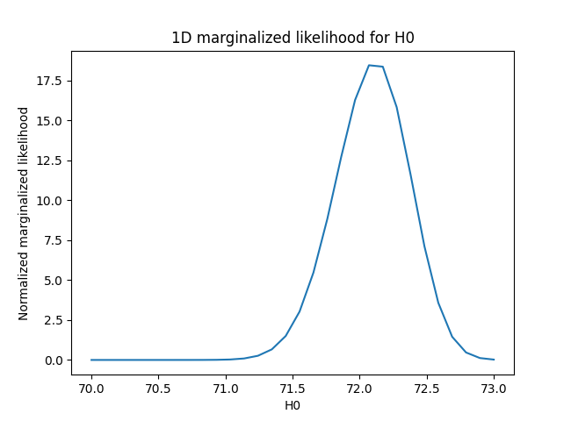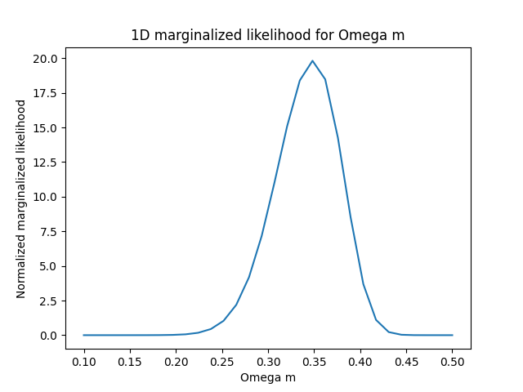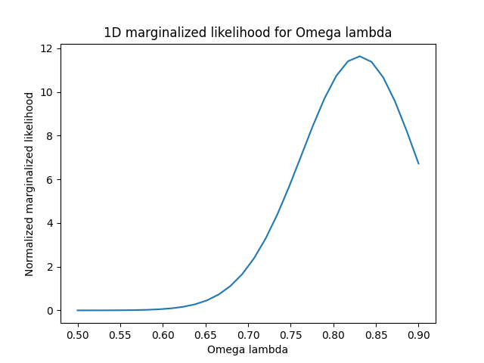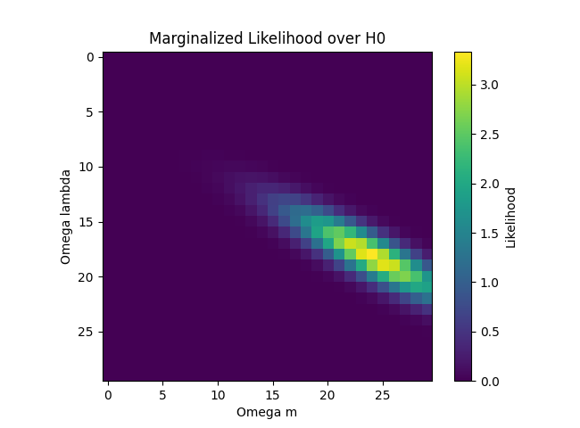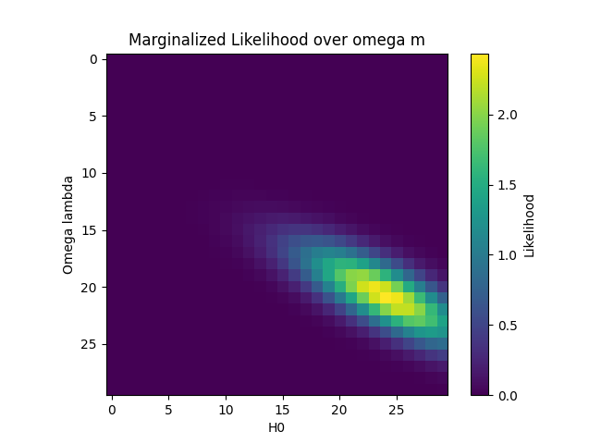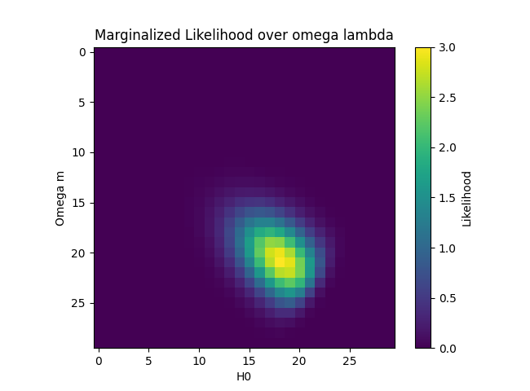

4.2
Burn in: It was determined that the first 200 steps of the log-likelihood can be ignored in analysis due to the burn in period. After steps=200 the log-likelihood stops sharply increasing and wonders around the fixed value.
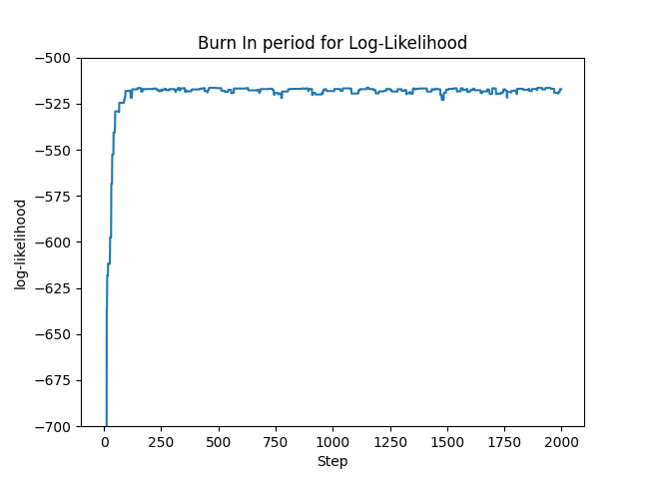

Analysis: For 20000 sample steps, relatively smooth 1D histograms of the parameters were achieved. A 3D scatter graph was also plotted, with omega lambda represented in colour, as seen below.
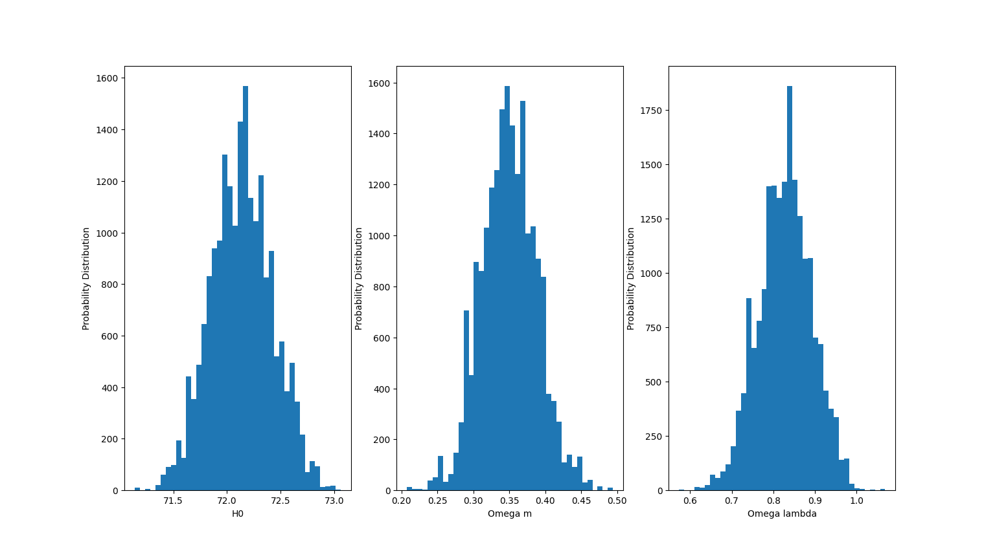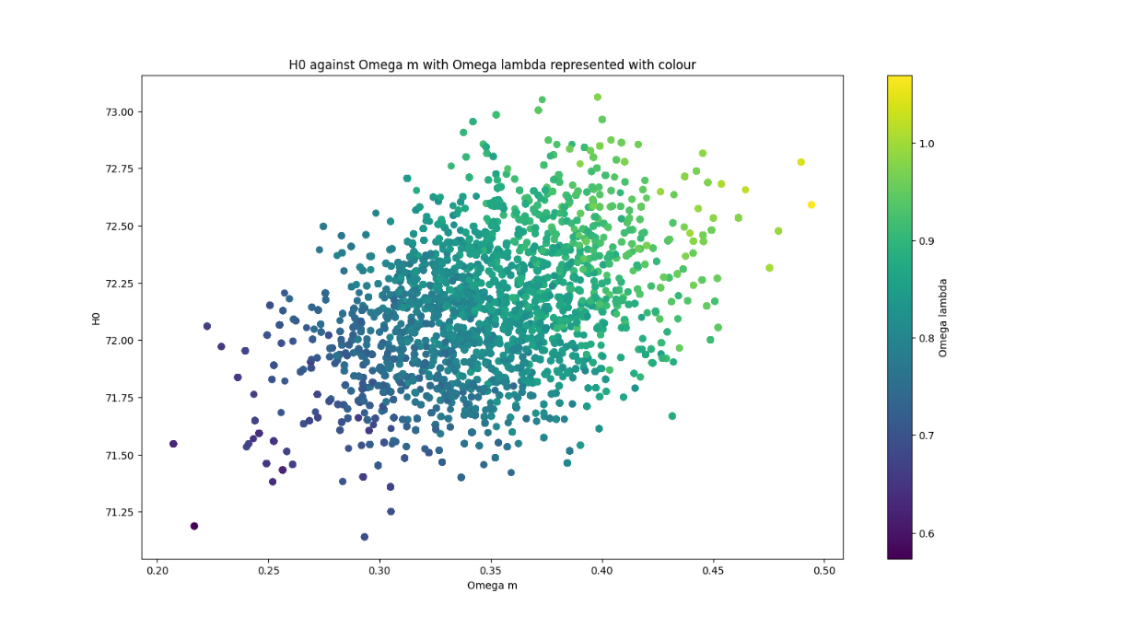
The peak parameter values for the likelihood grids agree well with the median values in the 1D Metropolis graphs, especially for omega m and omega lambda. The MCMC gives smoother curves due to the high density of sampled pointes where the probability is the highest, while the likelihood grid is more sensitive to changing parameter ranges.

